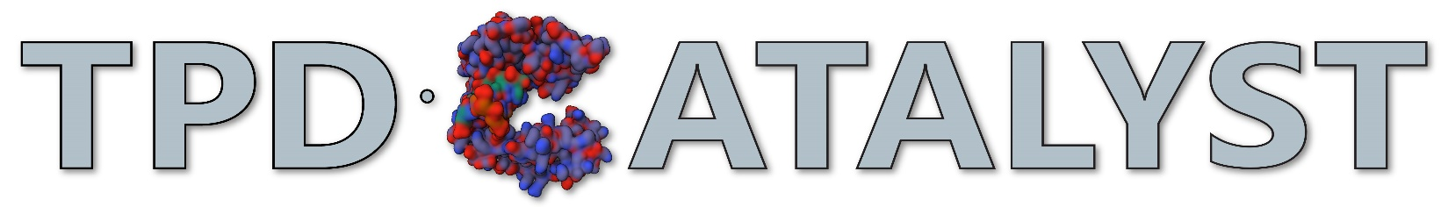

Option 2 (TPD Assignments): Submission Template

TPD Facilitator Context:
[Use this space to provide notes for facilitators. What is the purpose of the assignment? What might facilitators need to think about when presenting the information? What contextual variables might need to be considered? Are there any potential concerns that can be front-loaded or anticipated? What else might they need to successfully incorporate this assignment into their TPD programming?]

TA Assignment Instructions:
[Use this space to provide the instructions for any assignment stages as they would be presented directly to TAs.]

Assignment Rubric(s) [adjust point values to your context]:
[Provide rubrics for any assignment stages using the template below, in the language they would be used by TPD providers and/or presented to TAs completing the assignment(s). Add rows and columns as needed to add more criteria or levels of mastery.]
Assignment Title (and Stage, if relevant) [Total Point Value]
Criteria | Exceptional | Satisfactory | Cursory
Criterion 1 | Description of assignment products meeting this level. | Description of assignment products meeting this level. | Description of assignment products meeting this level.

Authorship and Attribution:
© [INSERT AUTHORS], [YEAR]
This educational resource is licensed under a Creative Commons Attribution-NonCommercial-ShareAlike 4.0 International License (CC BY-NC-SA 4.0).

You are free to:
- Share: Copy and redistribute the material in any medium or format.
- Adapt: Remix, transform, and build upon the material for non-commercial purposes only.

Under the following terms:
- Attribution: You must give appropriate credit, provide a link to the license, and indicate if changes were made. You may do so in any reasonable manner, but not in any way that suggests the licensor endorses you or your use.
- NonCommercial: You may not use the material for commercial purposes. For purposes of this license, "commercial use" means primarily intended for or directed toward commercial advantage or monetary compensation.
- ShareAlike: If you remix, transform, or build upon the material, you must distribute your contributions under the same license as the original.
- No additional restrictions: You may not apply legal terms or technological measures that legally restrict others from doing anything the license permits. For more details about the license, please visit the Creative Commons website at: https://creativecommons.org/licenses/by-nc-sa/4.0/

